Whitewater Rafting Site Plan

# Purpose

## Goals

# Target Audience

## Scenarios

# Site Map

# Branding

## Logo

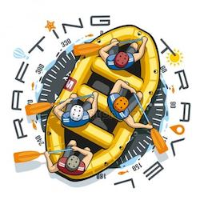

# Style Guide

## Color Schema

Color palette URL: <https://coolors.co/7d6533-337ca0-fdb813-4b5354>

* primary-color  : #337CA0
* secondary-color  : #4B5354
* accent1-color : #FDB813
* accent2-color : #7D6533

## Typography

* heading-font : Bebas Neue
* text-font : Open Sans

# Wireframes

## Wireframe Design for Rafting Project About Us Page

